

JULY

LIDLING ON CHURCH



www.lidlingtonchurch.org.uk

Sunday 30th June

Welcome to

10.45am –United Service with Stewartby and worship led by The AJ’s

with Linda and Siân

**Dates for July**

**Tues 2nd Hour of prayer –**

7 – 8pm in the Chapel

**Weds 3rd Lunch club –**

12.30pm in the hall

**Tues 16th Breakfast at coffee morning**

Served 10 – 11.45am in the hall

**Tuesdays Coffee morning –**

10am – 12md in the hall

**Home group** – 12.15pm Call Linda 402647

**Wednesdays Home group** – 8pm.

Call Jeff 402647

**Thursdays Prayer group** – 1.30pm in the lounge fortnightly

()

|  |  |  |  |  |
| --- | --- | --- | --- | --- |
| **July** | Time | **Service** | Musicians | Rock |
| 7th | 10.45am | **Morning Communion**  With Tim Mason | AJ’s | Linda |
| 14th | 10.45am | **Morning Worship**  With Joseph | AJ’s | Debbie |
| 21st | 10.45am | **Morning Worship**  With Stephen Plummer | AJ’s | Diane |
|  | 6pm | **Evening Communion**  Rev Quentin Chandler | Jeff | *--* |
| 28th  *New Wine* | 10.45am | **Morning Worship**  With Glynn Rowlands | Tim | Anna & Tallulah |

Together with gift aid and a donation made directly to Latin Link our total fundraising effort was a magnificent £480.  We have requested that the money is split equally between the prison project and supporting Julie personally.

**Next week…. Church family lunch at Emberton Park**

*(Olney Rd, Emberton, Olney MK46 5FJ)*

After the service we will load up the cars and head straight to the park. There is a £4.50 entry fee per car. When arriving at the park, you are allowed to take cars onto the grass and park where you wish to pitch. Please bring a picnic & drinks with you (there is a café for refreshments and ice cream).

The funeral of Vera Morrow will be on Thursday 4 July at 12.30pm in St Mary’s Church, Marston.

The cremation will take place at 1.45pm at Norse Road, Bedford, with the wake at Moreteyne Manor, Marston.

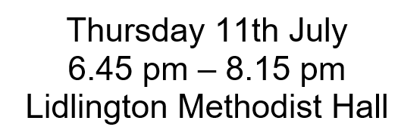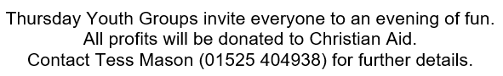

**Local Contacts**

**Lidlington Church Leaders:**

Jeff Bulled: 01525 402647

Tim Mason: 01525 404938

Siân Hiscocks (Pastoral): 07856 924058

Rev Caroline Weaver (Methodist): 01234 348091

Rev Quentin Chandler (Anglican): 01525 840477

Hall Bookings: Jean Peall**:** 01525 280059

*The Newsletters and weekly Pews News can be sent by E-mail. Please send a note to:* [**lidlingtonchurch@gmail.com**](mailto:lidlingtonchurch@gmail.com)